First create a newfolder nd pit scenariolauncher in that folder
Open that folder in terminal
execute these command
chmod +x scenariolauncher

sudo ./scenariolauncher init
(weve to give ip nd port given by teacher )

then sudo./scneriolauncher start
whatever we put ip nd port in init same weve to put here
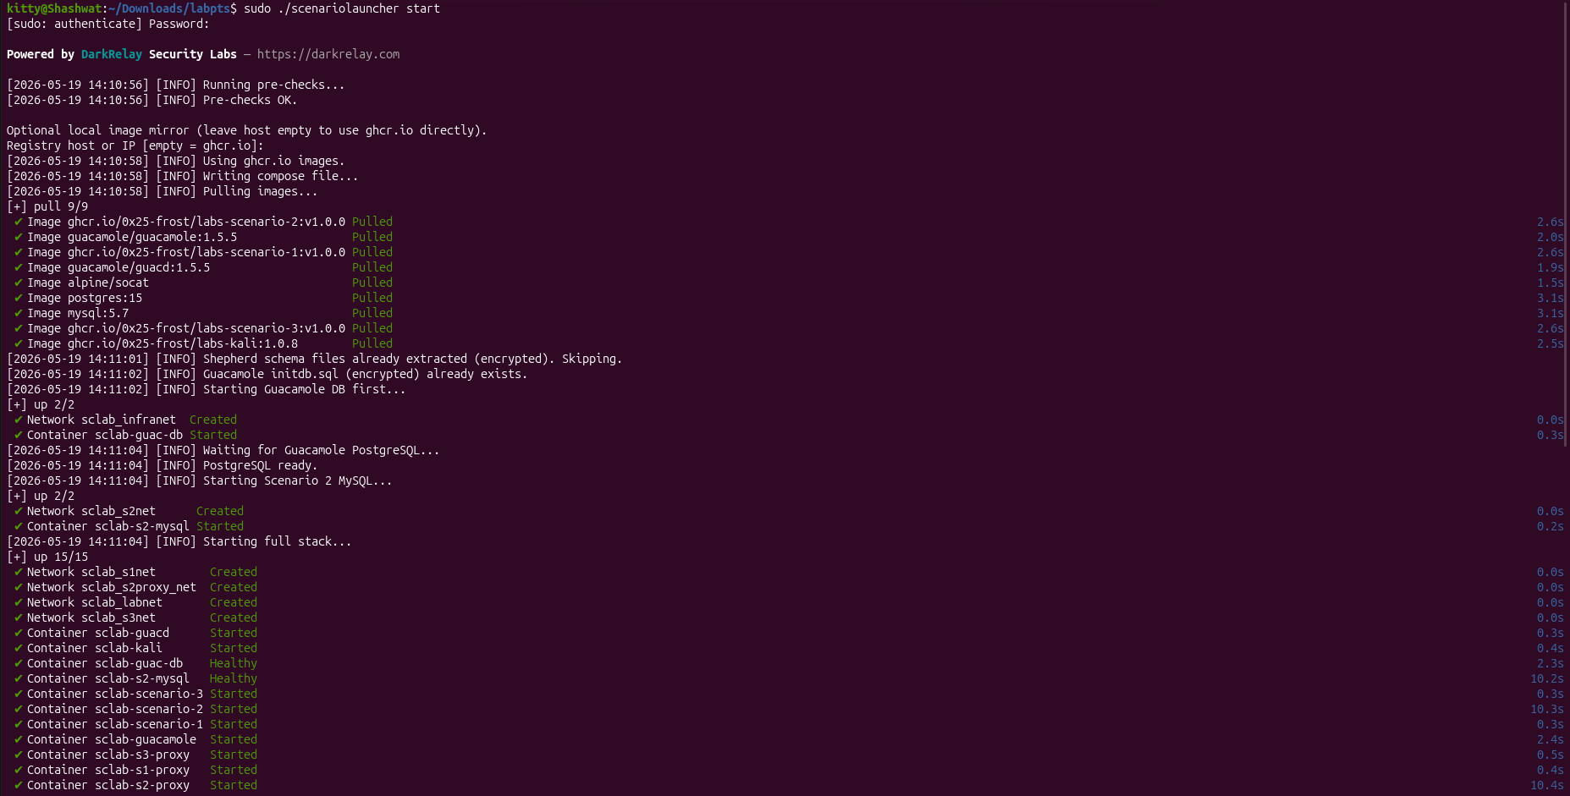
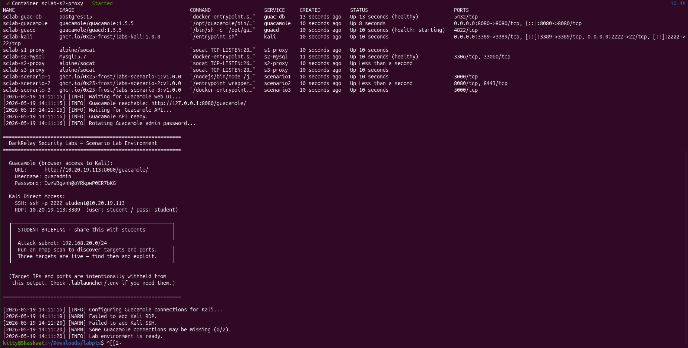
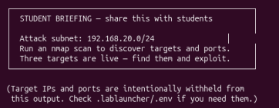
after acessing kali using web
open terminal nd run the cmd

nmap -sn ip (weve put ip whatever in student briefing )

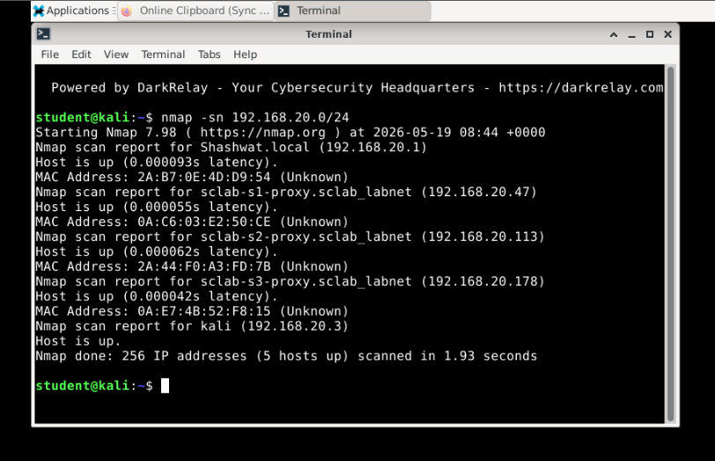
here basically 1nd 3 for internal communication ignore it
other 47,113,178 r vuln

now we ve explore ip nd find open port using below cmd

nmap -p- ip (ignore the –min-rate 50000
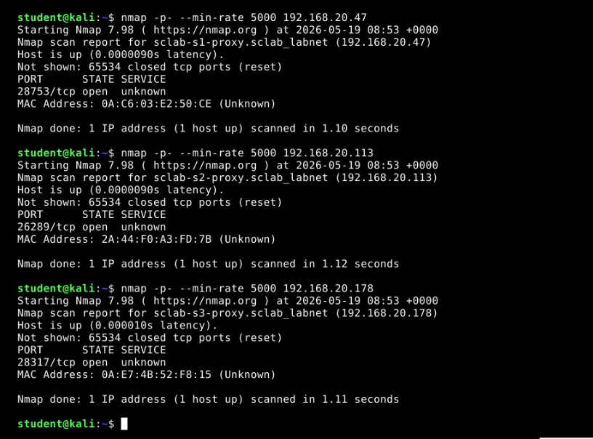

Open nanocorp bites web here 192.168.20.178:28317 (ip:port)
then go signup page nd sign in then go to login page

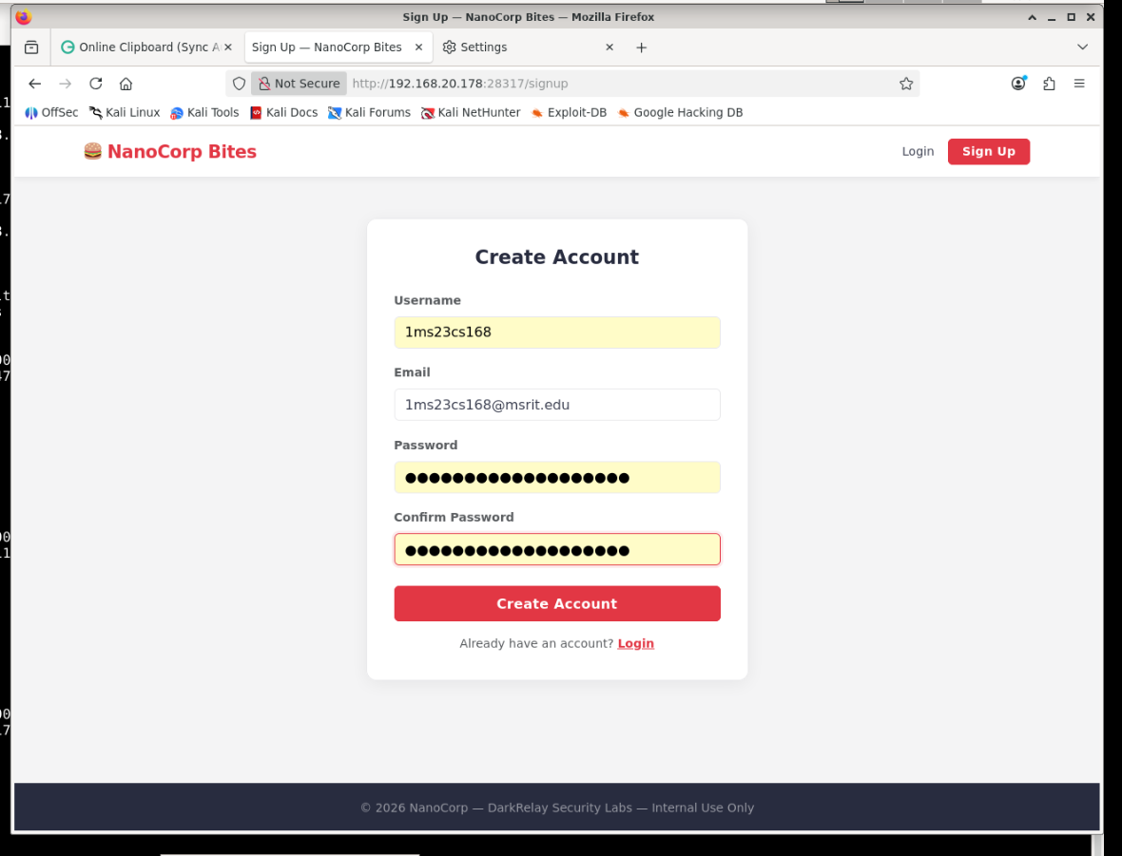
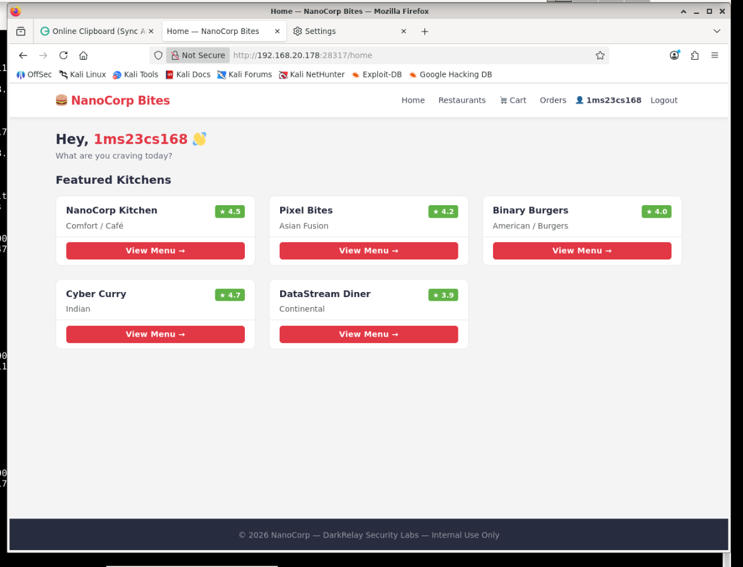

now go to resturant tab nd in search put insert the below cmd

Reflected XSS test
In input box:
<script>alert(1)</script>
If popup appears → XSS
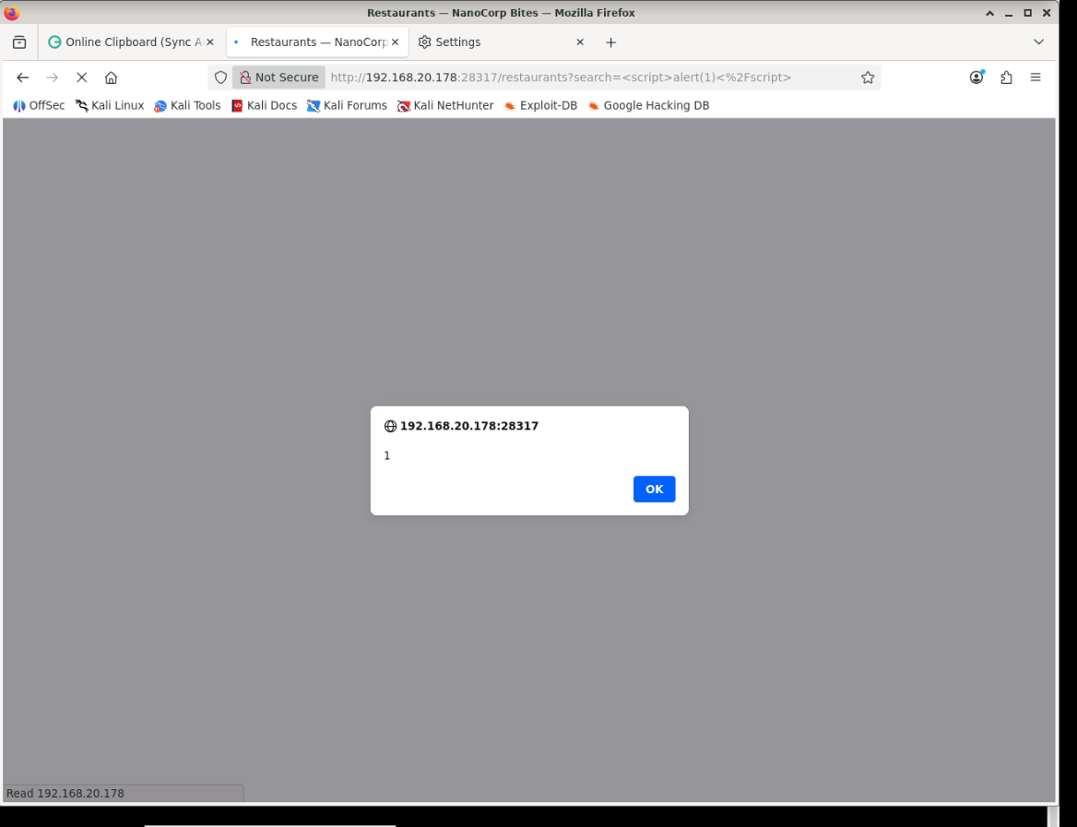

CVSS v3.1 Metrics

Metric Value

Attack Vector (AV) Network (N)
Attack Complexity (AC) Low (L)
Privileges Required (PR) None (N)
User Interaction (UI) Required (R)
Scope (S) Changed (C)
Confidentiality (C) Low (L)
Integrity (I) Low (L)
Availability (A) None (N)

Vector String

CVSS:3.1/AV:N/AC:L/PR:N/UI:R/S:C/C:L/I:L/A:N

https://nvd.nist.gov/vuln-metrics/cvss/v3-calculator?vector=AV:N/AC:L/PR:N/UI:R/S:C/C:L/I:L/A:N&version=3.1

2) Using Zap find vuln
run below cmd

zaproxy
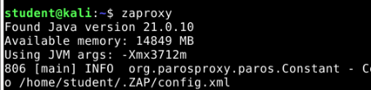

after open zap
go to firefox setting>proxy
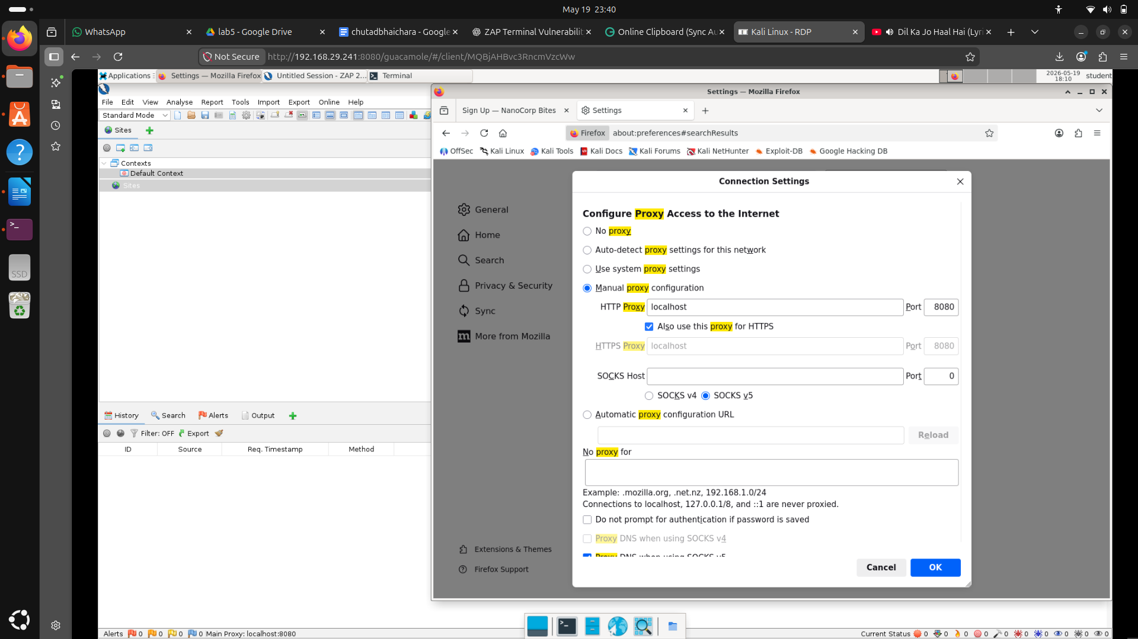
now go to zap
go to setting>network>server certifcate
save the certifcate

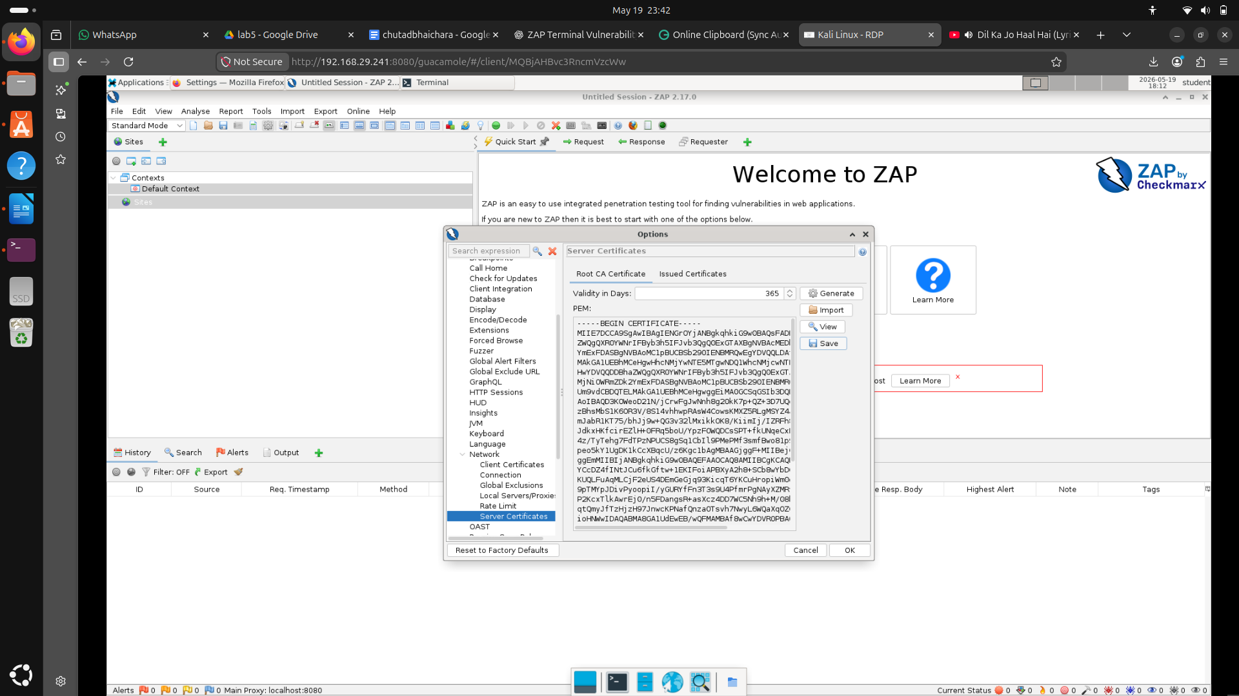
after saving go to firefox setting > certficate>import certifcate

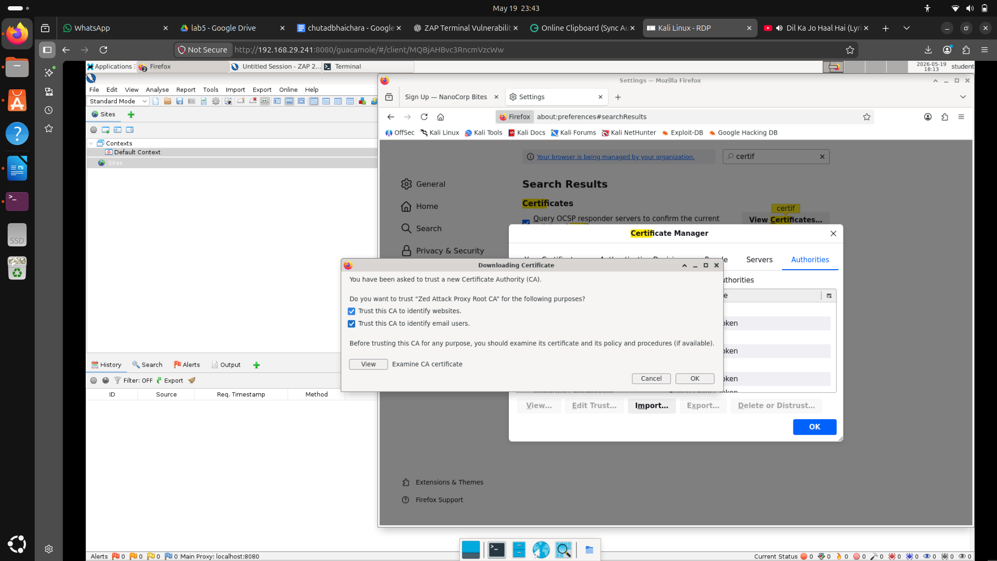
in firefox go open nanocorp bites nd register account nd login
after login go to resturant tab

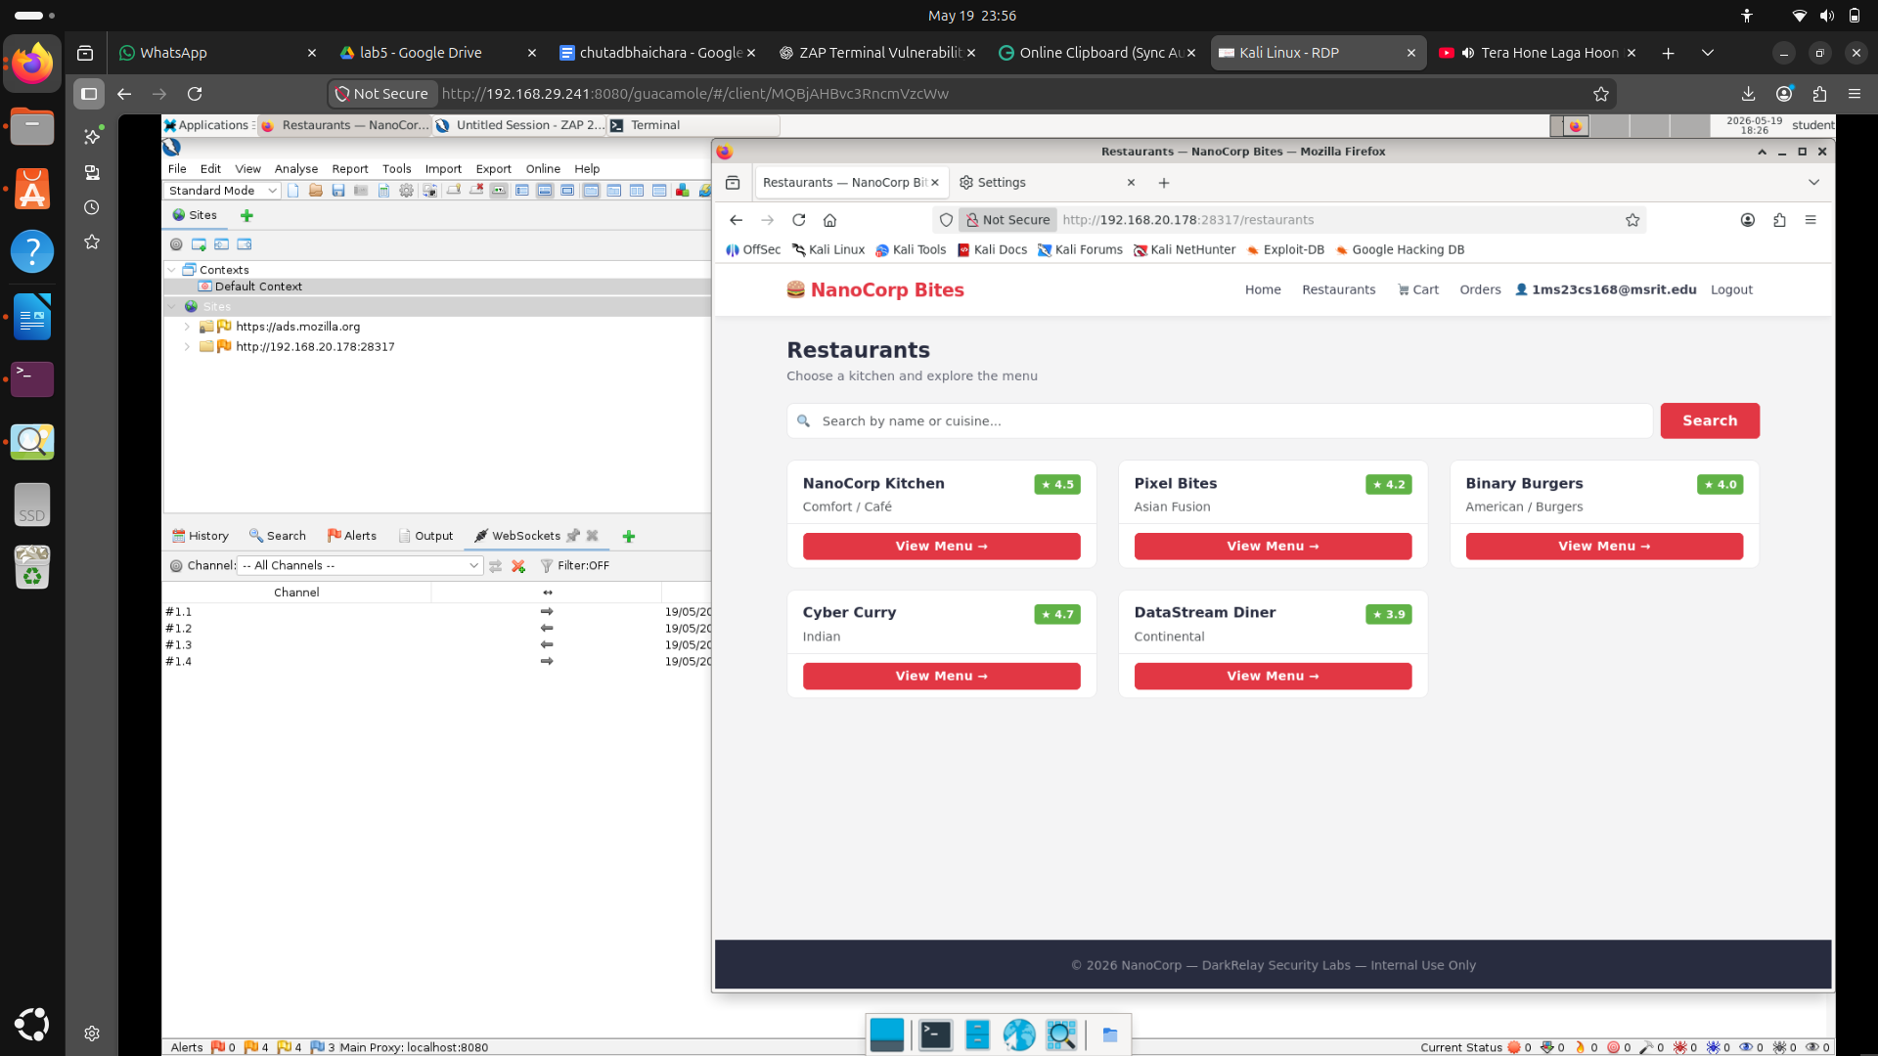
now go to zap
nd go to alert we all get alerts

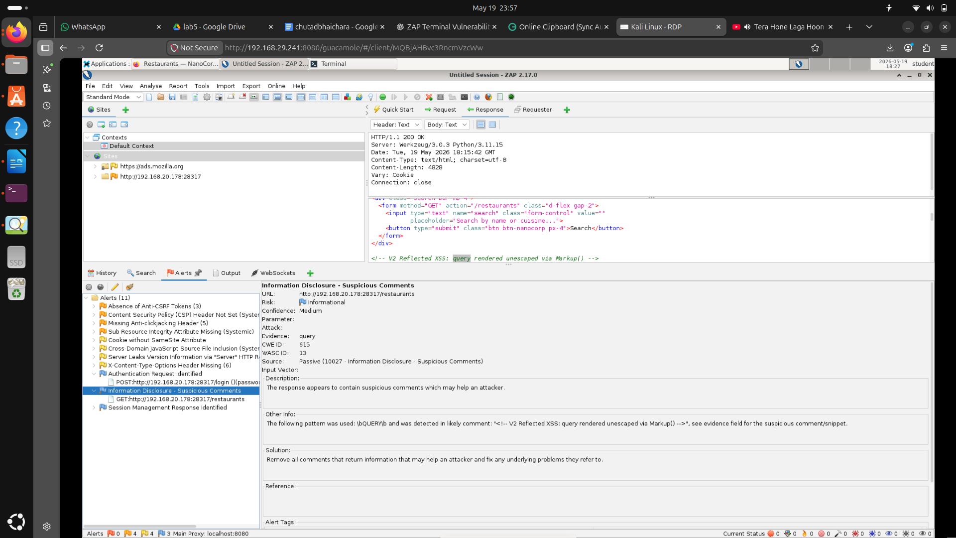
3) burpsuite

now go to firefox>setting>proxy

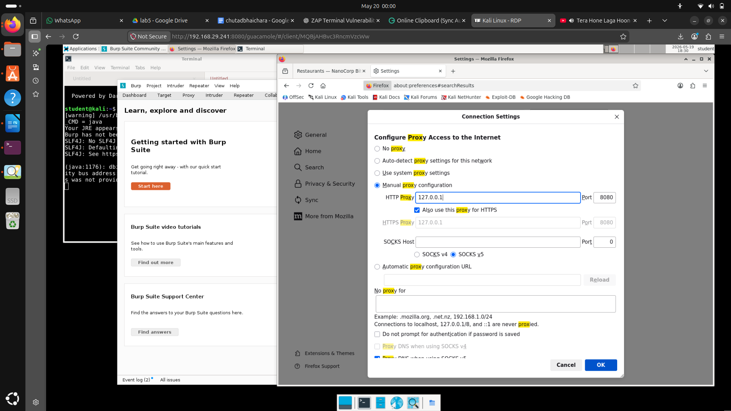

now turn on intercept on

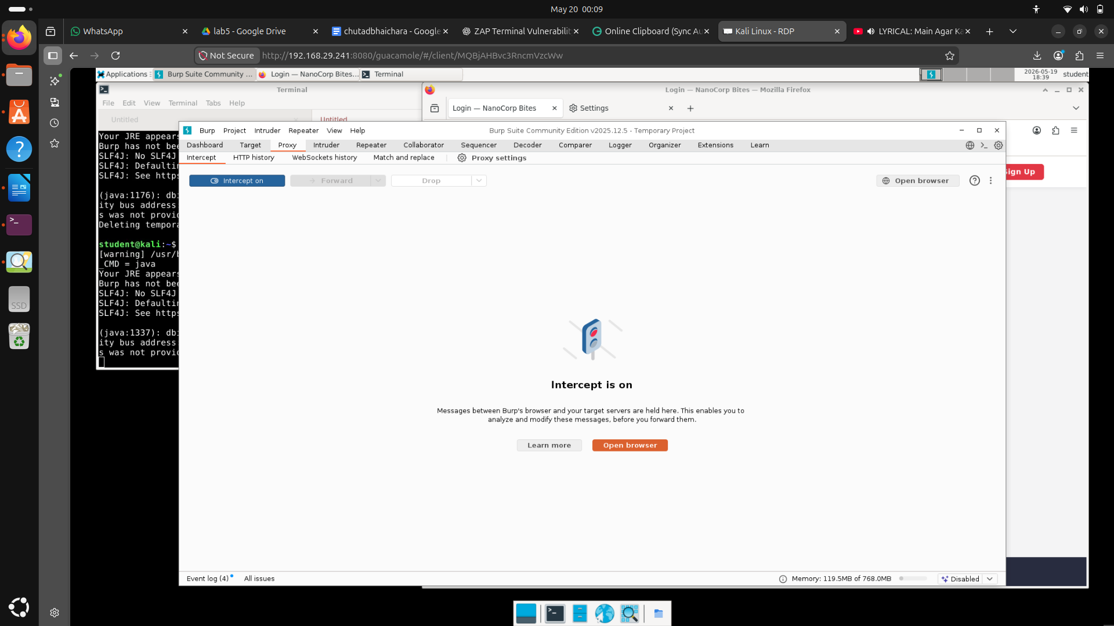
go to signup page nd in intercept forward all the url cmg
after creating account now go to login page nd in burpsuite forward url nd sent to repater
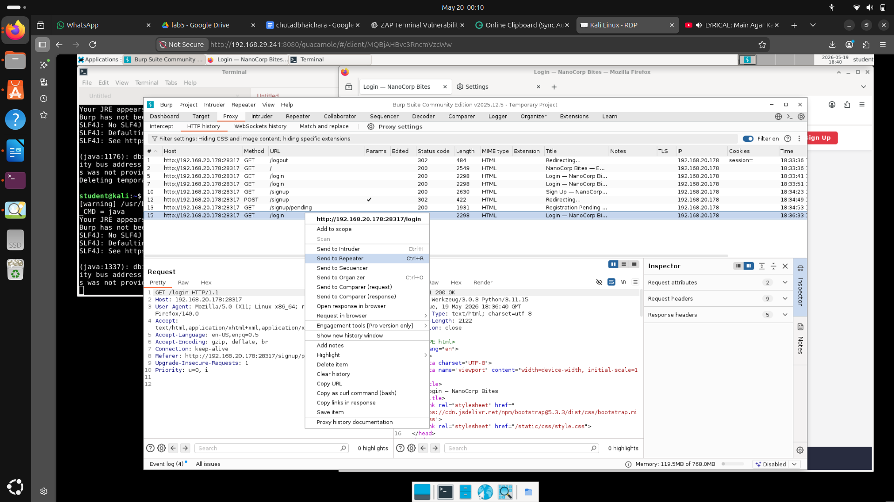
after send to repeater change the upgrade insecure request from 1 to 0 then click send
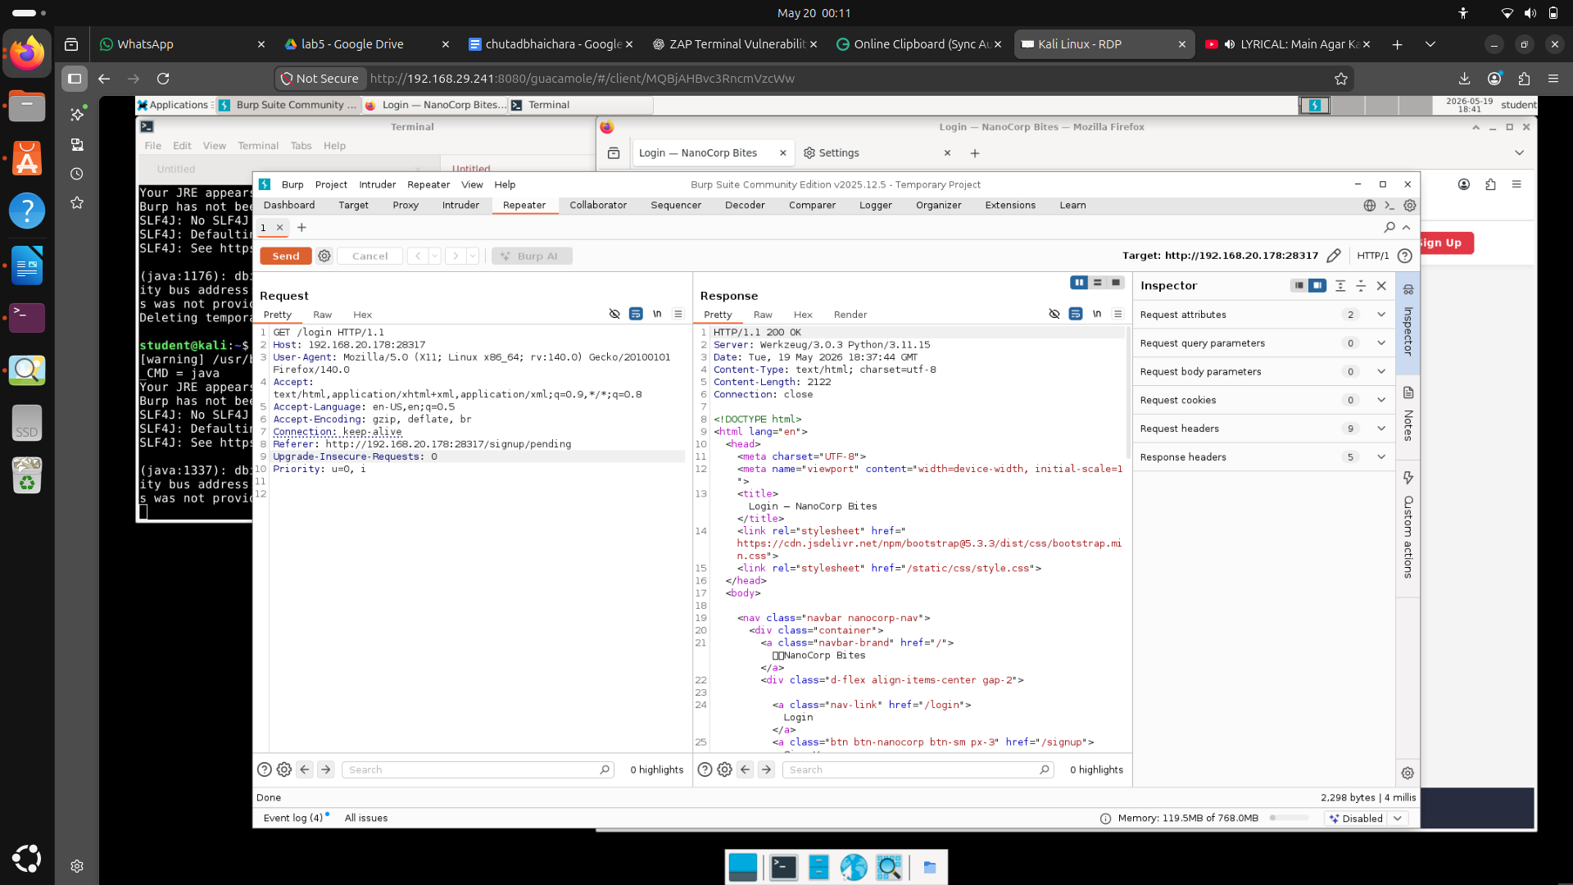
CVSS v3.1 Metrics

Metric Value

Attack Vector (AV) Network (N)
Attack Complexity (AC) Low (L)
Privileges Required (PR) Low (L)
User Interaction (UI) None (N)
Scope (S) Unchanged (U)
Confidentiality (C) Low (L)
Integrity (I) Low (L)
Availability (A) None (N)

Vector String

CVSS:3.1/AV:N/AC:L/PR:L/UI:N/S:U/C:L/I:L/A:N

https://nvd.nist.gov/vuln-metrics/cvss/v3-calculator?vector=AV:N/AC:L/PR:L/UI:N/S:U/C:L/I:L/A:N&version=3.1

4) Missing Anti-Clickjacking Header Vulnerability

open mousepad
use goonline clipboard code – 259283 copy nd paste the file give as clickjack.html
then open using firefox

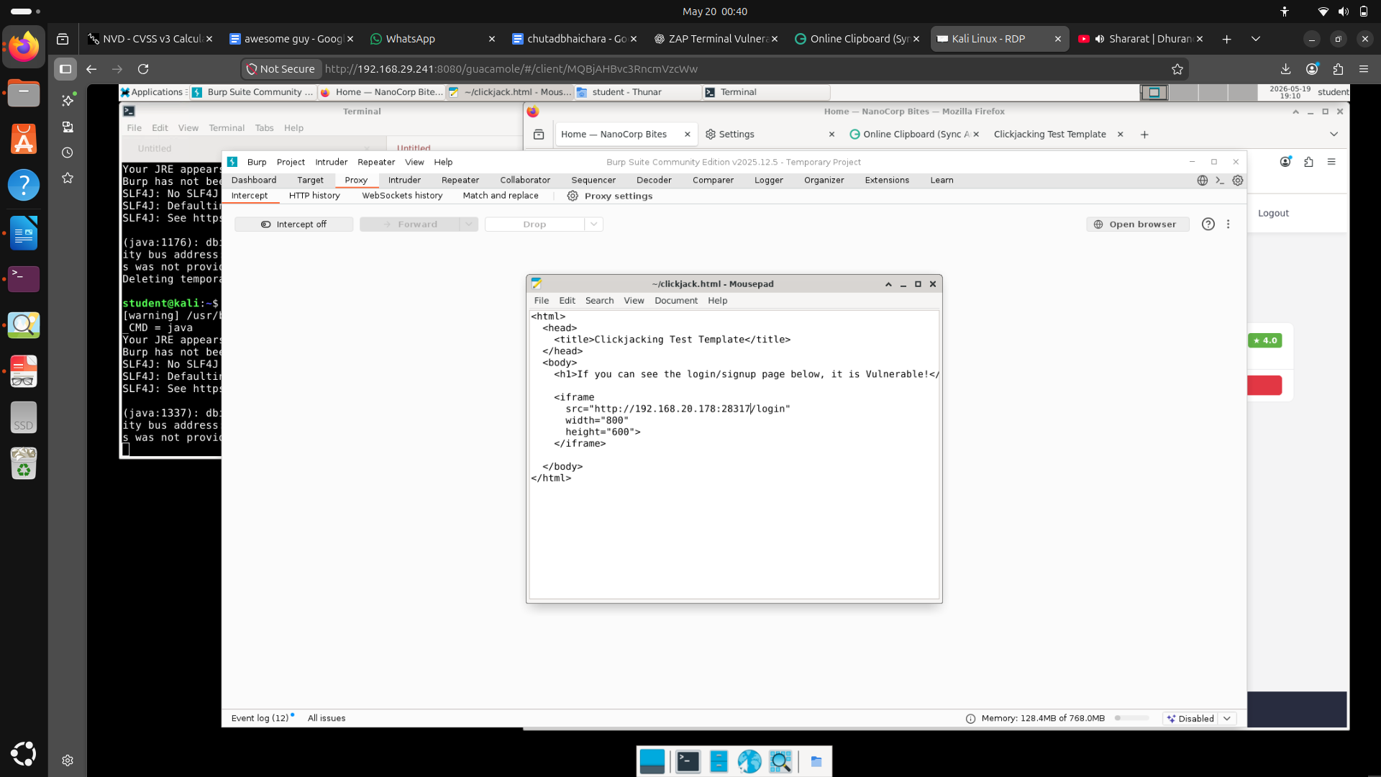

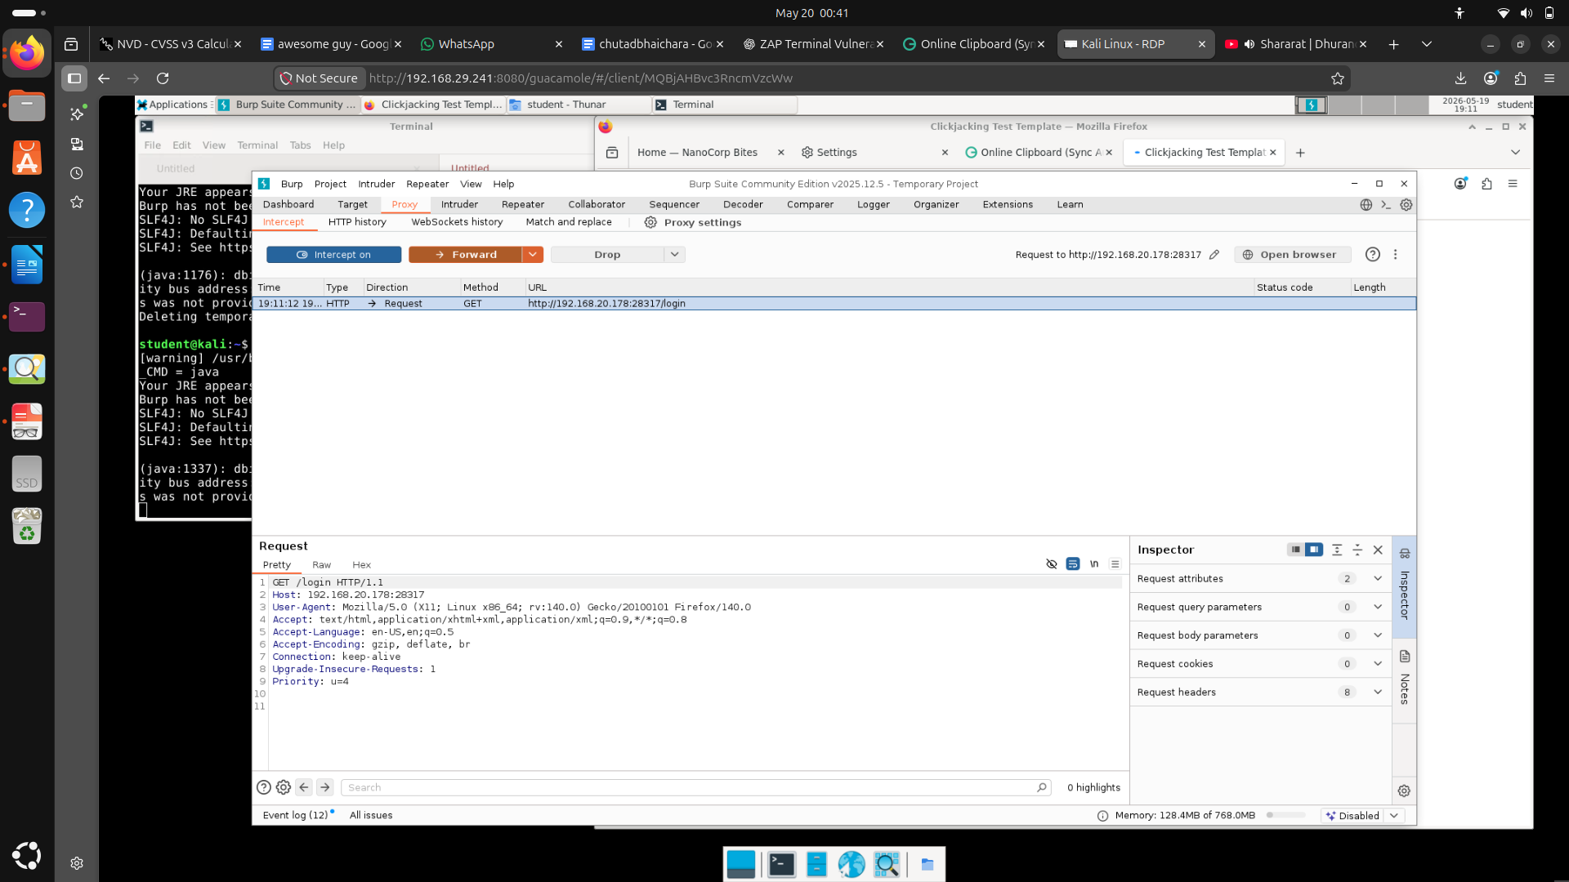

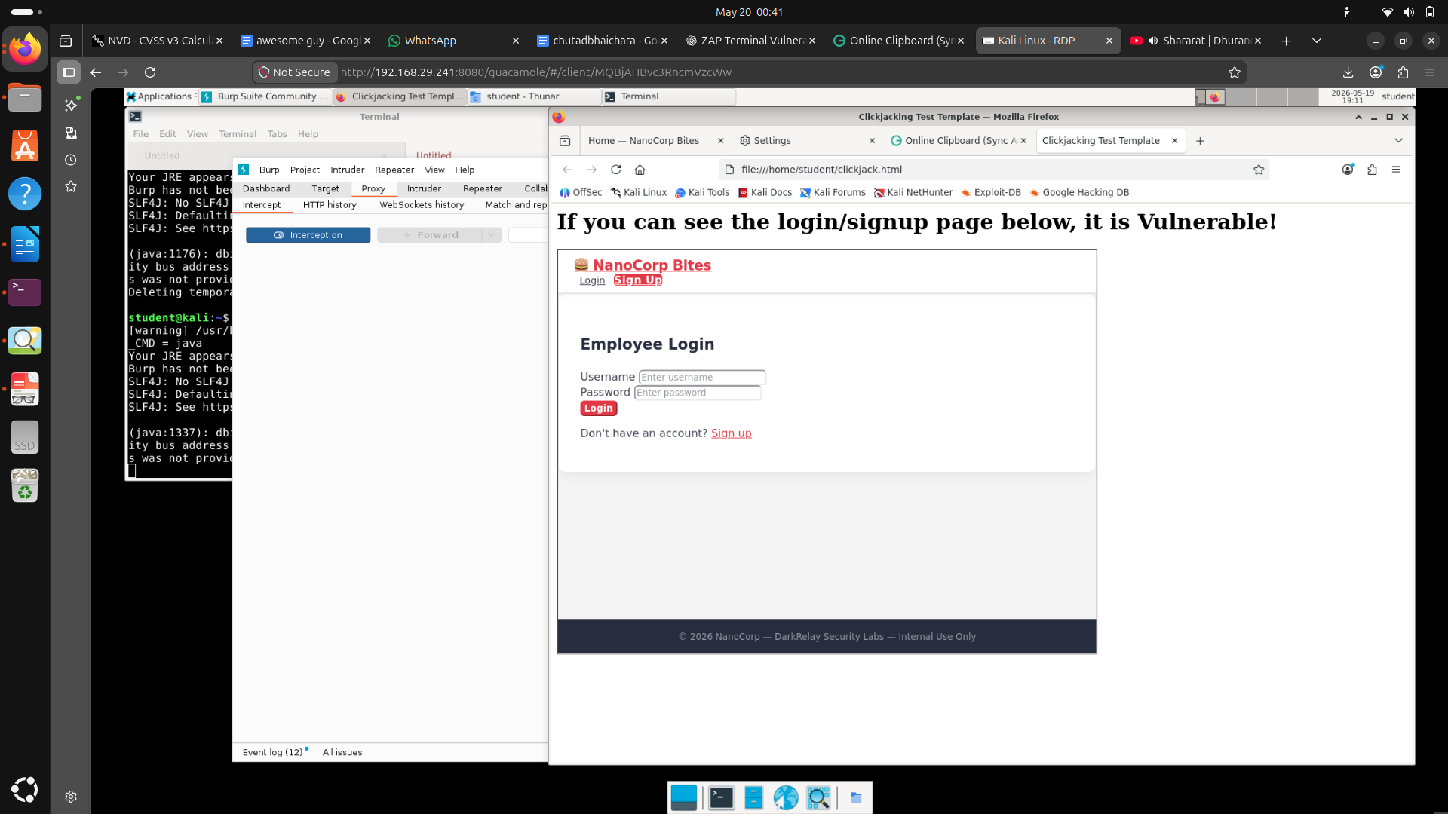
CVSS v3.1 Metrics

Metric Value

Attack Vector (AV) Network (N)
Attack Complexity (AC) Low (L)
Privileges Required (PR) None (N)
User Interaction (UI) Required (R)
Scope (S) Changed (C)
Confidentiality (C) Low (L)
Integrity (I) Low (L)
Availability (A) None (N)

Vector String

CVSS:3.1/AV:N/AC:L/PR:N/UI:R/S:C/C:L/I:L/A:N

https://nvd.nist.gov/vuln-metrics/cvss/v3-calculator?vector=AV:N/AC:L/PR:N/UI:R/S:C/C:L/I:L/A:N&version=3.1

5)Missing X-Content-Type-Options Header Vulnerability
open zaproxy
inspect the login page of nanocorp bites press f12 >networktab>refresh>click on login (blue clr) observe the resposne header notice that X-Content-Type-Options: nosniff absent so its issue
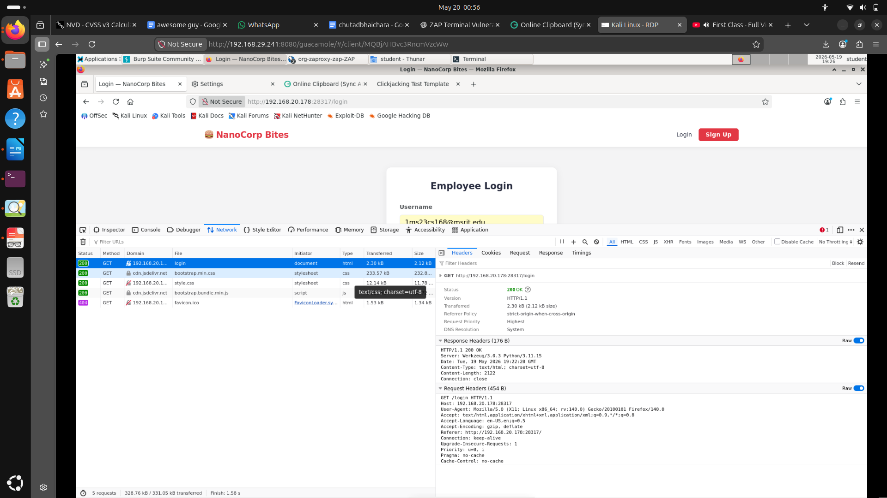
CVSS v3.1 Metrics

Metric Value

Attack Vector (AV) Network (N)
Attack Complexity (AC) Low (L)
Privileges Required (PR) None (N)
User Interaction (UI) Required (R)
Scope (S) Unchanged (U)
Confidentiality (C) Low (L)
Integrity (I) None (N)
Availability (A) None (N)

Vector String

CVSS:3.1/AV:N/AC:L/PR:N/UI:R/S:U/C:L/I:N/A:N

https://nvd.nist.gov/vuln-metrics/cvss/v3-calculator?vector=AV:N/AC:L/PR:N/UI:R/S:U/C:L/I:N/A:N&version=3.1

6) Server Version Information Disclosure
as above response header

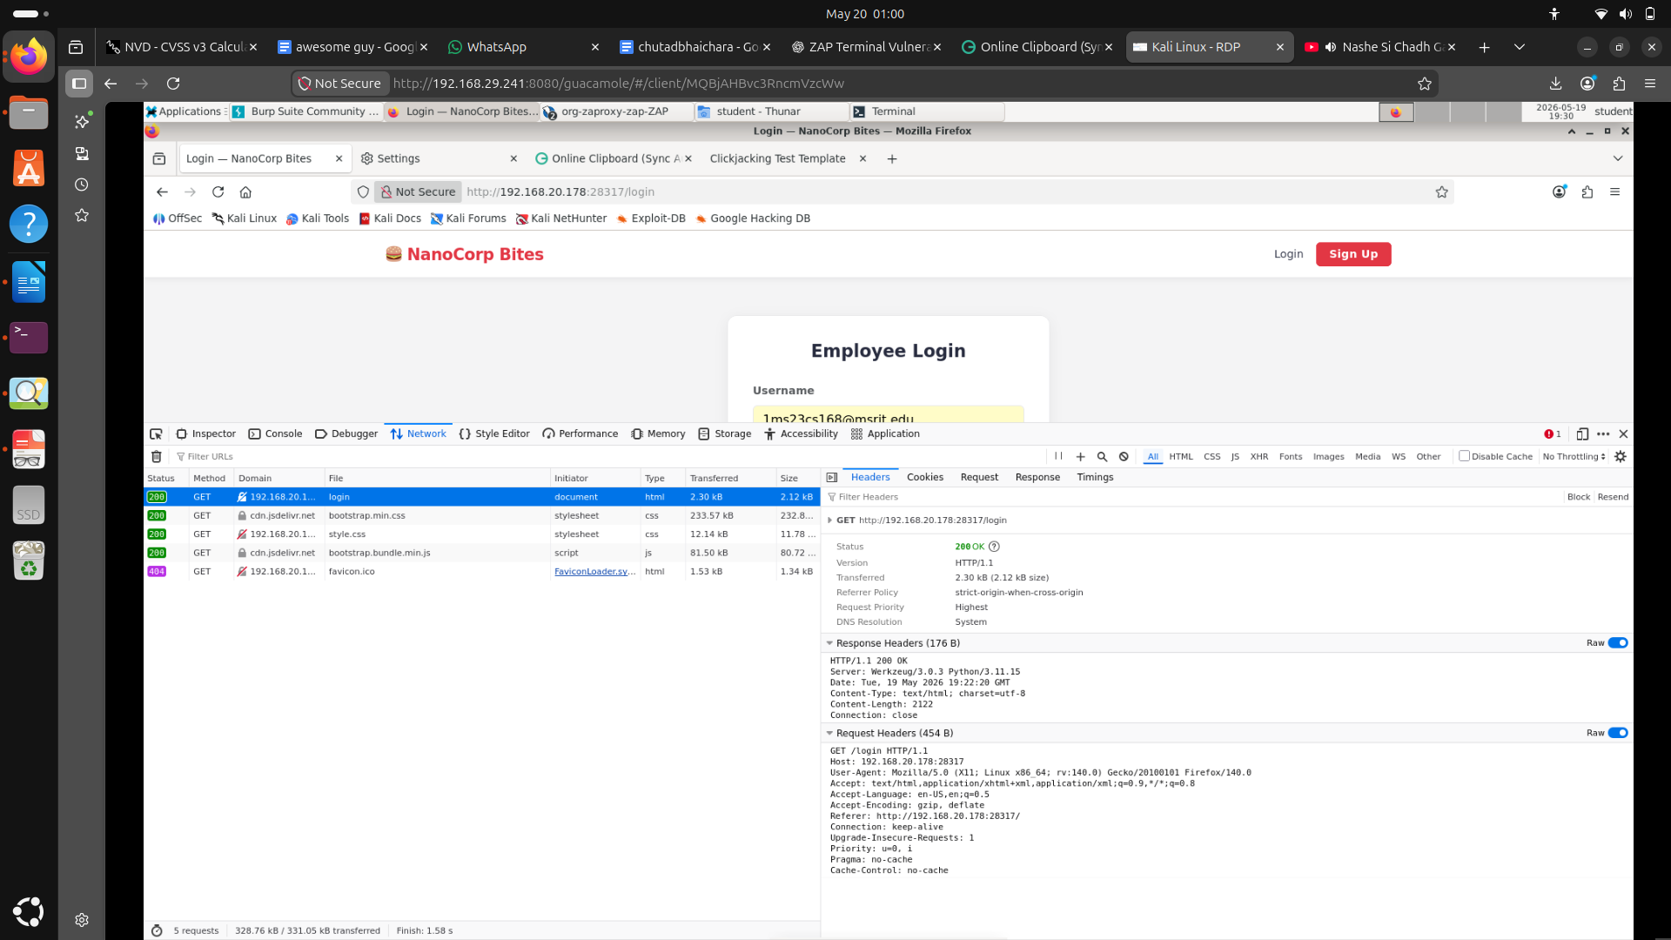
we observe that info vuln
HTTP/1.1 200 OK Server: Werkzeug/3.0.3 Python/3.11.15 Date: Tue, 19 May 2026 19:22:20 GMT Content-Type: text/html; charset=utf-8 Content-Length: 2122 Connection: close

CVSS v3.1 Metrics

Metric Value

Attack Vector (AV) Network (N)
Attack Complexity (AC) Low (L)
Privileges Required (PR) None (N)
User Interaction (UI) None (N)
Scope (S) Unchanged (U)
Confidentiality (C) Low (L)
Integrity (I) None (N)
Availability (A) None (N)

Vector String

CVSS:3.1/AV:N/AC:L/PR:N/UI:N/S:U/C:L/I:N/A:N

https://nvd.nist.gov/vuln-metrics/cvss/v3-calculator?vector=AV:N/AC:L/PR:N/UI:N/S:U/C:L/I:N/A:N&version=3.1

